CURRICULUM VITAE

DON FRANCIS CARVALLO

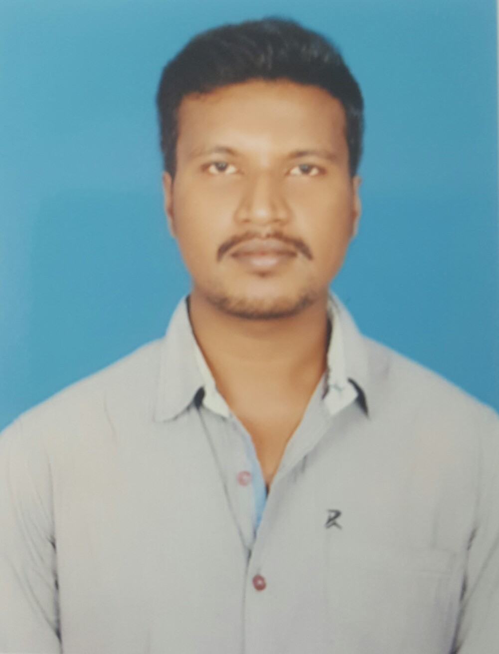 DON FRANCIS CARVALLO
S/O ANTHONY THOMAS CARVALLO,
NO 6/8010, 6TH CROSS
UDAYAGIRI, MANDYA
KARNATAKA , INDIA
Mobile no: +91 8553820459
Email:francessurya5@gmail.com

Objective:

- To be a part of growing organization that is thriving on the latest technology, which gives a challenging career, in terms of accomplishing the responsibilities.
- To optimize my Technical Training and Experience and to improve myself by continuous learning of Communication skills and Responsibilities, through which I can contribute to the progress of the Organization.
- To Excel in work through Dedication and Total Commitment.

QUALIFICATION:

Academics: 10TH std from ST JOHN’S HIGH SCHOOL,MANDYA

Job Profile

Industry : Auto mobile
Current location : Bangalore, Karnataka, India

Jobs carried out in ADVAITH MOTORS Pvt Ltd. Bangalore, India
(JUNE 2007 - JANUARY 2017)

- Engine dismantling and assembling.
- Mahindra :-215,245,255,295,265,395,405,415,475,575,585,595,444,555,605,
- 7575,8085, etc
- All tractors modals
- Gear box dismantling and assembling.
- Overhauling rear axles
- Cylinder head testing and valve lapping
- De-riveting clutch plates and brake shoes.
- Annual service
- Fault tracing in engine and other transmission related units
- Pre delivery inspection etc.
- Wheel alignment
- Periodic Service & Maintenance
- Deferential dismantling and assembling.
- Break relative relay valve repair
- Hub Related works
- Clutch related jobs done in vehicle
- Hydraulic Related works

Experience : Total Experience 10 years

- Present working at Mahindra Service Dept ,Advaith Motors pvt Ltd.
Bangalore.

COMPUTER SKILLS

- Basic knowledge in Microsoft office ie.excel, word, PowerPoint etc.

PERSONAL DETAILS

Name : DON FRANCIS CARVALLO

Father’s Name : ANTHONY THOMAS CARVALLO

Permanent Address : S/O, Anthony Thomas Carvallo
No 6/8010, 6th cross
Udayagiri, Mandya
Karnataka. India.

Date of Birth : 25-06-1988

Sex : Male

Religion : Christian (Roman Catholic)

Nationality : Indian

Email : francessurya5@gmail.com

Language Skill : English: Read-Write-Speak
Hindi & Kannada: Read-Speak
Tamil-speak
Hobbies : Reading books, Travelling, Gym, Bike riding
Football, Swimming.

Strengths : Self-confidence, communicating skills

Date:- 13-05-2017

Place:- AMERICA
DON FRANCIS CARVALLO

( Applicant )

